DMV/Donate Life Month Proclamation
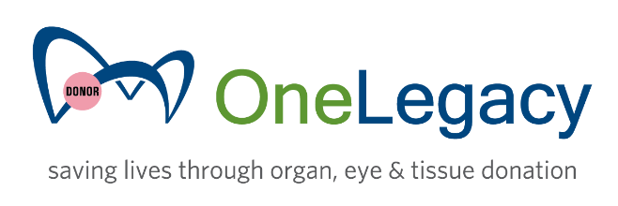
City of ______________________
April 2023
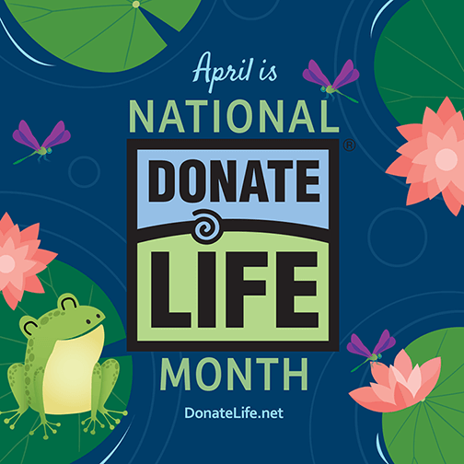
WHEREAS, organ, eye, tissue, marrow and blood donation are life-giving acts recognized worldwide as expressions of compassion to those in need;
WHEREAS, more than 100,000 individuals nationwide and more than 20,000 in California are currently on the national organ transplant waiting list, and on average, 17 people die each day while waiting;
WHEREAS, the need for donated organs is especially urgent in Hispanic, Latino, and African American communities;
WHEREAS, a single individual’s donation of the heart, lungs, liver, kidneys, pancreas and small intestine can save up to eight lives;
WHEREAS, donation of tissue can save and heal the lives of more than 75 others;
WHEREAS, organ donors saved more than 42,000 lives last year, the most ever;
WHEREAS, any person can register to be an organ, eye and tissue donor regardless of age or medical conditions;
WHEREAS, being a registered donor does not impact the quality of life-saving medical care a person receives in an emergency;
WHEREAS, California residents can sign up with the Donate Life California Donor Registry online at any time by visiting www.donateLIFEcalifornia.org or, for Spanish-speakers, www.doneVIDAcalifornia.org
WHEREAS, California residents can sign up to be an organ, eye and tissue donor when applying for or renewing their driver’s licenses or ID cards at the California Department of Motor Vehicles;
WHEREAS, California residents interested in saving a life through living kidney donation may visit www.LivingDonationCalifornia.org;
NOW, THEREFORE, BE IT RESOLVED that in recognition of National Donate Life Month, the month of April 2023 is hereby proclaimed “DMV/Donate Life Month” in the City of ______________________, and in doing so we encourage all Californians to check “YES!” online, or when applying for or renewing their driver’s license or I.D. card at the DMV.

